# **Visualization**

1. Sales and Advertising

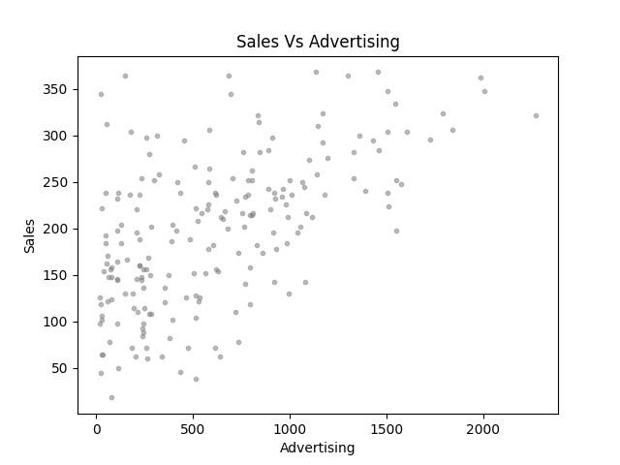

1. Sales and Airplay

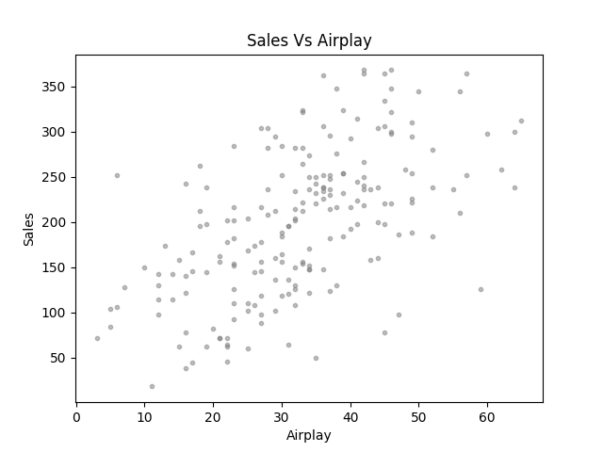

1. Sales and Attractiveness

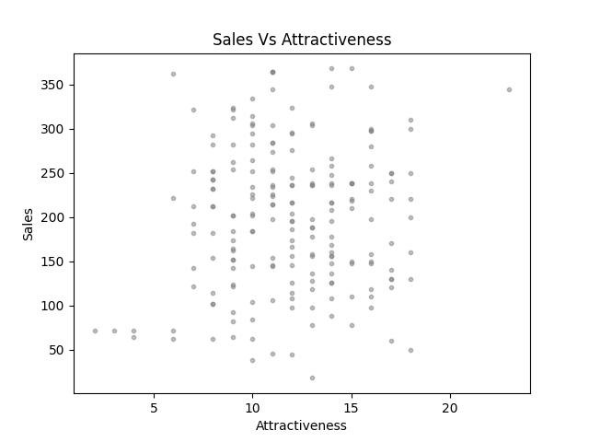

# **Linear Regression**

1. F-statistic = **98.04421577660042**

P-value = **4.946499173591105e-19**



1. The value of F-statistic = 98.04421577660042 indicates that the prediction improvement made by our linear regression model is 98.04421577660042 times better than the difference between the model and observed values. This signifies that our model can explain 98.04421577660042 variabilities compared to the extent it can't explain. In simple terms, our model is 98.04421577660042 better than the actual bad model.

The value of F-statistic greater than 1 is better. Here, our value of 98.04421577660042 is relatively high. Therefore, we can conclude that this model is good.

The P-value = 4.946499173591105e-19 indicates a 4.946499173591105e-21% probability that our data can be false. In simple terms, our model has a 4.946499173591105e-19 chance that the tests are False Positive.

The P-value less than 0.05 is considered better. Here, our value of 4.946499173591105e-19 is relatively low. Therefore, we can conclude that this model is good.

# **Model Coefficients**

1. Intercept value = **139.59312007800236**

Coefficient (Adverts) value = **0.09551716452262707**



1. Records that will be sold if we spent $135,000 on advertising the latest album “Dear Agony” by Breaking Benjamin = **13034.410330632658**



# **Multiple Regression**

1. F-statistic = **105.2**

P-value = **1.27e-40**

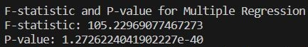

1. The R-squared value for Model 1 is 0.331 whereas the R-squared value for Model 2 is 0.617. The R-squared value measures the proportion of the variance in the dependent variable that is predictable from the independent variable(s). Having higher values for R-squared indicates a better fit of the model to the data. Therefore, Model 2 is better in comparison with Model 1.